Biochemical Data

Goals and Objectives

-explain the relationship between the Philadelphia chromosome and CML

-describe the function of the BCR-Abl fusion kinase

-discuss the mechanism of imatinib action

-define the association and dissociation equilibrium constants in terms of reaction concentrations

-calculate the KD of a biomolecular reaction from a hyperbolic binding equation from a graph of data

-illustrate a first-order dissociation reaction

-estimate the half-life for the decay of the reactants from a first-order dissociation reaction

-plot biochemical data using MATLAB

**Fitting experimental biochemical data – equibrilium and kinetic data**

**Why do we care about defining these biochemical parameters? CML, BCR-Abl and imatinib**

CML – 1-2 per 100,000 people

Treated with tyrosine kinase inhibitor Gleevec or imatinib

Before that, you had about 30% five-year survival – now it’s 90%

We know in detail how it works biochemically and these biochemical parameters help us understand why

CML is associated with a characteristic chromosomal translocation – a break and fusion between the *abl* gene on chromosome 9 and the *bcr* (breakpoint cluster region) region on chromosome 22 – known as the Philadelphia chromosome

It generates bcr-abl which has kinase activity. Abl is a kinase implicated in control of the cell cycle. In normal cells, the Abl kinase is subject to regulation by cell cycle checkpoint proteins. However, cells with the Philadelphia chromosome produce a constitutively active BCR-Abl fusion protein that is not subject to regulation. Thus, the BCR-Abl fusion protein initiates a signaling cascade that speeds up cell division, leading to cancer.

**BCR-Abl kinase is responsible for CML development and imatinib is a competitive inhibitor**

The figure below illustrates the activity of the BCR-Abl fusion protein. The Abl portion of the protein has kinase activity, meaning it can take a phosphate group from ATP and transfer it to a substrate protein (or other substance). This reaction yields adenosine diphosphate (ADP) and a phosphorylated substrate. The phosphorylated substrate protein then goes on to initiate a signaling cascade that leads to cell proliferation. Because BCR-Abl is constitutively active, its presence leads to uncontrolled cell proliferation and the development of cancer.

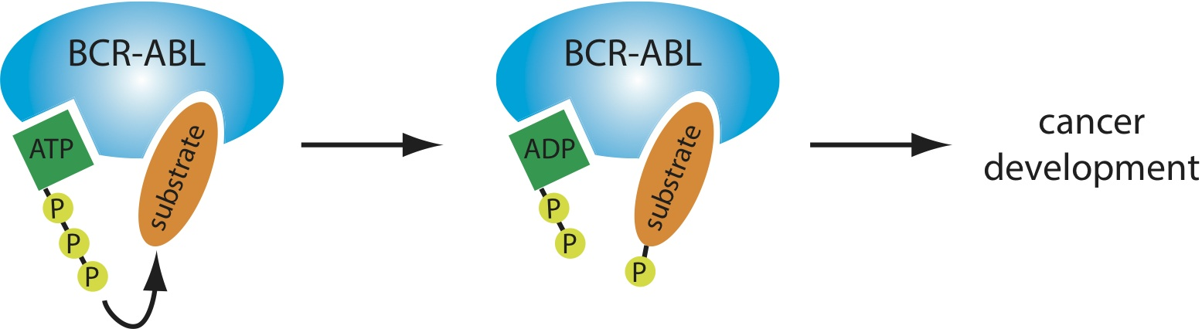

A major therapeutic strategy for CML treatment is to inhibit the BCR-Abl kinase by preventing ATP binding to it. One way to do this is by designing a drug inhibitor that binds tightly to the same site as ATP, thereby preventing ATP binding. This kind of molecule is called a competitive inhibitor.

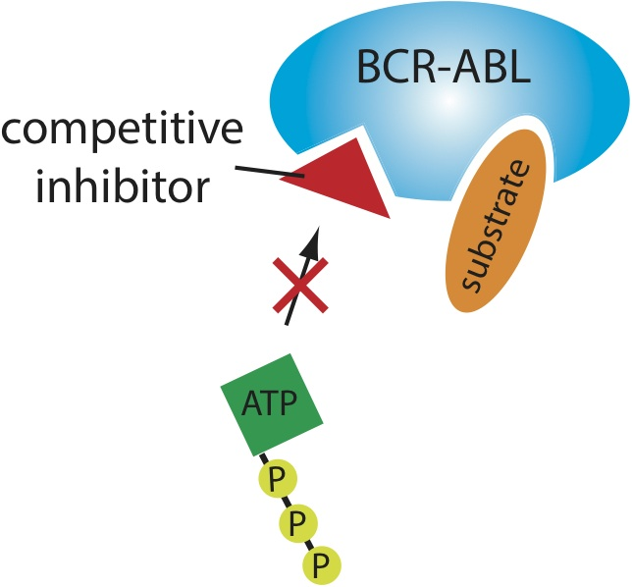

Gleevec is a competitive inhibitor of ATP for BCR-Abl. Without ATP, there is no phosphate to transfer to the substrate, there is no initiation of the signaling cascade, and there is no cancerous phenotype.

Let’s look in higher resolution at how these molecules and proteins actually look.

This is ATP:

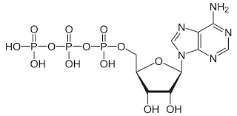

And this is imatinib:

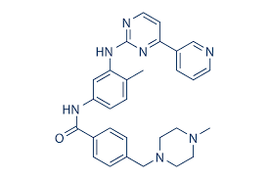

They share some aromatic ring structures, but for the most part they look pretty different. This is important because ATP participates in a massive number of reactions, and something that looks just like ATP would have off-target effects and likely kill cells or at least have limiting side effects. If you want to inhibit BCR-Abl specifically, you need something that just really binds BCR-Abl.

On the left is ATP binding to BCR-Abl in green, and on the right is imatinib binding to BCR-Abl in red.

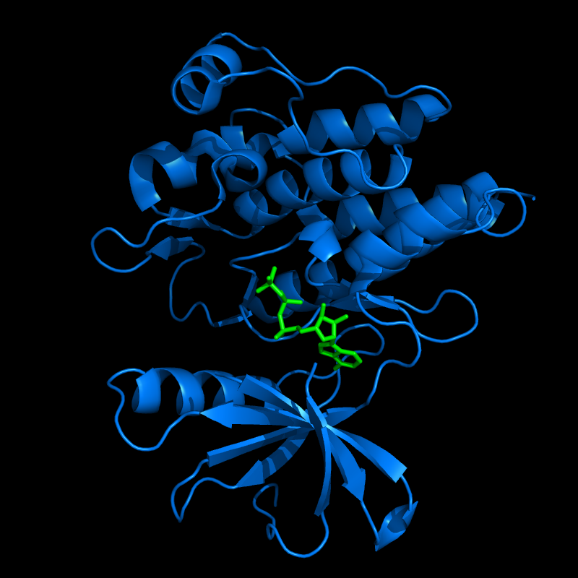 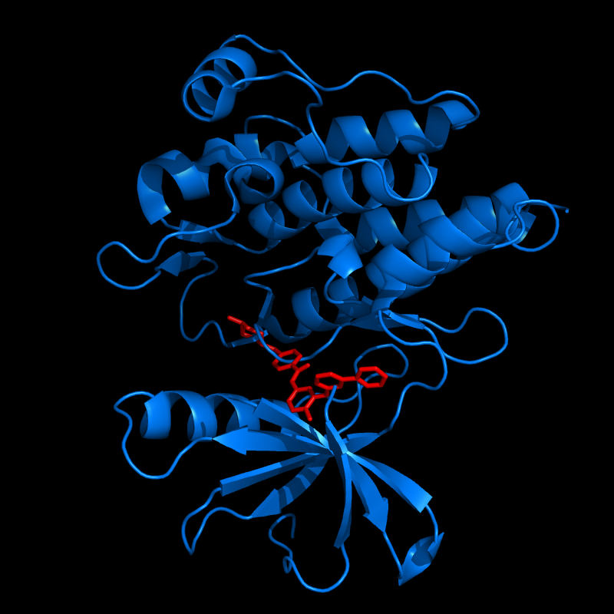

ATP and imatinib bind to the same site in BCR-Abl, the definition of competitive inhibition.

For imatinib to be an effective competitive inhibitor, it has to bind more tightly to BCR-Abl than ATP. ATP is present in the cell in large quantities, and since we are not going to get molar quantities of a drug into the cell we want our drug to be able to bind very tightly. (Furthermore, ideally we want it to bind BCR-Abl more effectively than wild-type Abl or other tyrosine kinases, but that may not be covered in this lecture.)

**The equilibrium constant**

How tightly does imatinib bind to BCR-Abl?

A + B ↔ AB

We need some kind of assay to determine whether we are at equilibrium – you need to make measurements. If you measure free A for example, and then wait a bit, and then measure free A later and it’s the same, then you’re at equilibrium

Let’s define some of these biochemical parameters that we use to talk about how tightly A associates with B

Equilibrium constants – big K

(small k has to do with kinetic processes)

KA = association constant

KD = dissociation constant

KA = [AB]/[A][B] M-1

KD = [A][B]/[AB] M

Biochemists typically discuss binding affinities in terms of KD because units of molar are easier to understand intuitively.

**Hyperbolic binding equation**

Assuming we have an assay to measure the fraction of B bound in the complex, we can experimentally determine the KD in this manner.

Fraction B bound = θB = [AB]/([B]+[AB]) = 1 / ([B]/[AB] + 1)

Substitute in the expression for KD:

1 / (KD/[A] + 1) = [A] / (KD + [A])

θB = [A] / (KD + [A])

NOTE This equation is only valid in this bimolecular reaction model A + B ↔ AB

If we graph this with [A]free on the X axis and θB on the Y axis, we get a rectangular hyperbola:

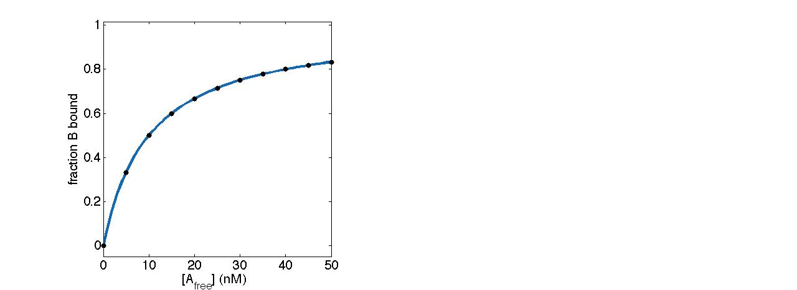

It’s really easy to know how much A you added to the test tube but harder to know how much A is free…but if we choose our initial concentration of B so it’s very low, then B is limiting:

If [B0] << KD then [A]total ~= [A]free

And we need no assay for [A] and can just use the total [A] in our calculations

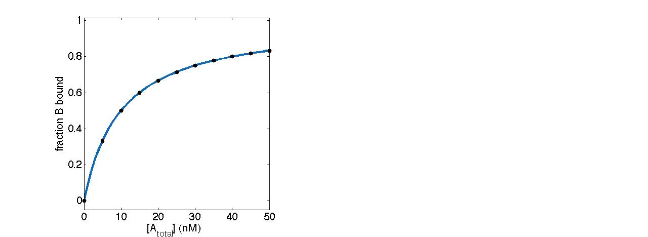

Note the changed x-axis.

When [A] = KD, θB = 0.5

You should make a full curve to determine your KD because you will have measurement error and then you can use all your data to see how your system behaves at all the different concentrations of A, and you can fit it all to a model and get a more accurate representation of the KD.